Final Project Design Phase
Computer Science - Week 11
Oct 3, 2026 - Version 0.0.4

For complete instructions and project ideas, refer to the assignment in Canvas. Specifically, review the final project requirements before you continue below. If you have not reviewed the project requirements in Canvas (you might have to go to the modules view and check the current or past week's content), you will not be able to properly complete the parts below. In addition, it may be helpful to review the information on this Drafter documentation page.

0) Project Planning and Preparation
Successful programmers spend time planning before they begin coding. After reviewing the project requirements, answer the following questions to help guide your design and development process.
- What concepts from class or previous assignments might help you complete this project? Which programming concepts (loops, conditionals, lists, classes, etc.) do you expect to use? What programming skills do you want to improve while completing this project?
The concepts of loops, conditional statements, lists, classes, and drafter will all be helpful in this assignment. I would like to improve my programming skills surrounding the implementation of drafter through this project.

- Which parts of the project do you expect to be the easiest for you? The hardest? Why?
I expect working with loops, conditional statements, classes, and lists will be the easiest for me since I understand them very well. The hardest part will be finding creative solutions to represent the user inputs, such as creating a class to represent a chemical compound.

- Even though you have not yet designed the final project, estimate which tasks will likely require the most time and effort? Which features or components should be implemented first?
Creating a dataclass to store the important information from a chemical formula will definitely take the most time to implement. The first feature I must implement is how the chemical formulas are inputted to the website in order to determine the best way to extract the information.

- What distractions might interfere with your work and how will you minimize them? What resources will you need available while working? What questions, if any, do you still have about the assignment requirements?

The distractions of other classes could distract from me working on this project, but overall, with access to the LLM and by setting aside time to code, I will be able to complete this project.

1) Site Diagram
Create a mock-up of your planned website. We suggest you make the mockup on paper, although you can also use software like PowerPoint or Slides to make a mockup. There is other design software that could also be used, but we strongly encourage you to keep it simple. Do not spend more than 15-30 minutes detailing the mock-up. Your goal should be to make a very quick and dirty diagram, to show that you have some kind of idea.

We recommend drawing each page as a rectangle, and laying out the text, buttons, and other components inside. Then, use arrows to indicate links between pages. Label each page the way you will name each function, and then put labels on the arrows to indicate what the button links. Also write down any parameters that should come into the pages.

In addition to the pages and routes, write down what fields your `State` will have, both their names and types. Think clearly about what data will need to be persistent across the entire website.

Add photo(s) or screenshot(s) of your website mock-up and labeled diagram on the next page.

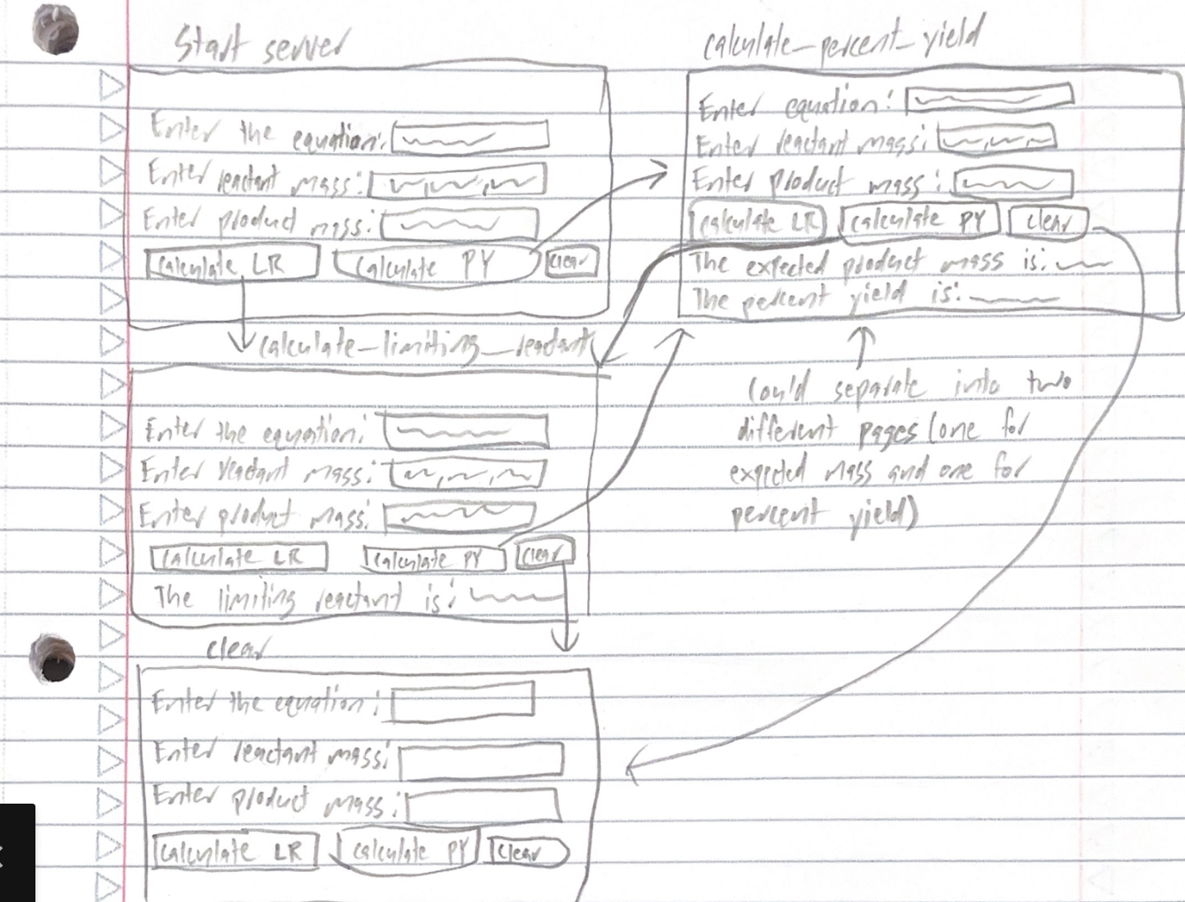

2) Implementing Requirements
This table should serve as a draft for how you will implement the requirements into your final project. You may change your ideas later on, but your final site must fulfill all the requirements.

Requirement | Implementation
Purpose/Functionality  A 1-2 sentence description of the purpose or functionality of your site | My site takes in a balanced chemical equation and the masses of the reactants to determine the limiting reactant and expected mass of the product produced. The site can also calculate the percent yield if given the mass of product produced.
State Dataclass Attributes  Minimum of 4 attributes, one of which must be a list/dict of instances of your second dataclass.  Briefly describe each attribute, its type, and how it will be meaningfully modified throughout the site. | List of reactant masses (list[float]) - will contain all of the masses entered into the reactant mass box.  Product mass (float) - will contain the mass entered into the product mass box.  List of molecules (list[Molecule]) - will contain the coefficients, chemical symbols, and subscripts of each molecule inputted in the balanced equation box.  Expected product mass (float) - will contain the calculated expected product mass based on the limiting reactant and balanced equation.
Second Dataclass  Your second dataclass, including its attributes, their types, and how they will be meaningfully modified (if they are modified) | Molecule  Coefficient: int - obtained through the balanced equation  Chemical_formula: list[str] - obtained through the balanced equation  Subscript: int - obtained through the balanced equation
Routes (minimum 7)  The names of your route functions | Index, get_molar_mass, calculate_limiting_reactant, calculate_percent_yield, calculate_product_mass, parse_reactants, parse_products, clear
Pages (minimum 5)  A brief description of the pages in your site | Start server page - a page featuring three textboxes where the user can input the blanched equation, reactant masses, and product mass.  Calculate limiting reactant page - a page featuring the calculated limiting reactant based on the equation and masses entered.  Calculate expected yield page - a page featuring the calculated expected yield based on the equation and masses entered.  Calculate percent yield page - a page featuring the calculated percent yield based on the expected yield and actual yield.  Clear page - a page featuring three empty textboxes the user can input a new equation and masses into, erasing the previously entered data.
User Input (minimum 3)  Description of user input components (TextBox, TextArea, CheckBox, or SelectBox) and their purposes  For more information on these input types, see Drafter Documentation. | Enter balanced equation textbox - used to enter the equation being worked with into the site.  Enter reactant mass(es) - used to enter the masses being worked with into the site to calculate the limiting reactant.  Enter product mass - used to enter the actual product mass into the site to calculate percent yield.
If Statements (minimum 3)  Brief description of what will be evaluated in your if statements and how they will meaningfully change the logic of the site | If statement one will be used to determine the reactant and product sides of the equation by searching for the arrow.  If statement two will be used to parse the reactant side of the equation and separate it out into lists that can be worked with.  If statement three will be used to parse the product side of the equation and separate it out into lists that can be worked with.
Loop (minimum 1)  This loop must iterate over the list/dict of dataclass instances in your State attribute.  Description of this loop and why it is meaningful to the site | This loop will iterate over the list of molecules in order to determine mathematically what the limiting reactant of the system is.

LLM Conversation
If you used an LLM in any part of this work, copy and paste every part of that conversation below. Otherwise, you may be given a zero for the assignment. Obviously, these words will not all be yours, and this is the exception to the requirement at the top of this assignment that all responses be in your own words. If you did not use an LLM to assist you in this assignment, simply say so below.
I did not use an LLM on this assignment

Final Submission
When you are finished, download this file as a Word Document (docx) and upload the file to the appropriate assignment on Canvas.

